- Rationale

The data structures I used for the assignment 2 program are the template binary search tree (bst) and STL map. The vector is not used in assignment 2.
In assignment 1, I used the vector to store all data after reading the value from the data file. However, in assignment 2, I change the data structure to map instead of vector.
The way I store data in the STL map:
- I create a struct that contains a Date class object and a Time class object. (called it dateTime)
- Store the dateTime struct object as the key of the map
- A WindLogInfo class object (weather) contains the value of average wind speed, average air temperature and solar radiation.
- The value of the map will be the WindLogInfo class object.
One of the reasons I used the STL map to store all data is to fulfil the requirement of assignment 2. Another reason is that the STL map does not allow duplicate key. Therefore, the map will handle all the duplicate records for me. In addition, each key (dateTime) will have a WindLogInfo class object (value) that contains all the required information. When calculating the required data for options 1-5, once I found the same dateTime object (key), I can simply retrieve the corresponding value. I think this approach/structure is more suitable and easier to understand and compile than the bst. That’s also the reason why I decided to use STL map to store data instead of bst.

The way I use bst:
- I used bst in the calculation of average wind speed, average air temperature and total solar radiation (GetAverageSpeed(), GetAverageAir() and GetTotalSolar()). I will pass in the STL map to the methods that do the calculation. After I prompt and get the date from the user, I will use thr for loop to search through the pass-in map and find the same key. Once I found the same key, I retrieved and stored the required data into a bst. My traversal method will call the function pointer and calculate the running total of all nodes and find max value (option 5) in the bst. I used bst to store and calculate the data because I wanted to make use of the method of bst, which is the function pointer and traversal. For example, I have a function called GetTotal() in CollectData class, which I will pass to the inorder traversal to calculate the running total of every node in bst. It is because this approach/structure is easier and faster when calculation the running total. In addition, my program does not need to use a loop to go through every record and calculate the running total because my bst will handle it for me. After completing the running total calculation, I will conduct other calculations and return the final value.

Another way I use bst:
- The requirement also requires that our program must have the ability to ignore duplicate data files. Therefore, I create a bst with string data type in the ReadDataFromFile() method. After I read and open a particular CSV file in the data folder, I will first check if my bst contains this file name. If the file name is not found in the bst (means no duplicate), I will store the particular file name into the bst and continue other operations. If found in the bst file (means duplicate), my program will skip everything in the if statement. I use bst because the searching performance of bst is o(log2n) time. In worst case, the time it takes to search an element is 0(n). Which I think is better than using the array.

- I use the file.eof() and break in the middle of the code inside my program instead of the beginning. It is because the eof() will always read an extra line even though there is no more data inside the met_index.txt file. Therefore, my program will check if there is more data in the file during the process instead of the beginning.

- I use struct to store Date class object and Time class object (dateTime) is because I consider this is just a combine package of Date and Time class object.

The way I handle global variable issue:
- Initially I created a function in main program to calculate the sum of all value in bst and another function to compare and find the largest value in bst. However, as mentioned in the lecturer, global variable is considered not good. Therefore, to resolve this issue I follow the given example in the testTree file which I create 2 new separate class to retrieve value from bst and calculate the require data. The first class is called Value. This class object contains a member variable, and it is used to store the value retrieve from bst. For example, I create a Value type bst and Value class object in GetAverageSpeed () function. Once I found the same key record, I will first set the value of wind speed to the value of Vector class object by using the SetValue() method. After that I will store this Value class object in the Value type bst. Therefore, my bst will contains many Value class objects for later use.

- Once the looping of map is complete, I will use the inorderTraversal() function and pass in the Sum() function in CollectData class object. The Sum() function will take in a Value class object and calculate the running total by retrieving the value of Value class object (using the GetValue() function). The bst will traverse and continue this operation, to calculate the running total and store it in the member variable m_total. Once the traversal is completed, I will simply use the GetTotal() function to retrieve the value of running total. After each call is completed, the destructor of Value class and CollectData class will set the member variable back to 0, so that the Value and CollectData class object can reuse.

- The calculation of average air temperature and total solar radiation are same.

- The calculation of highest solar radiation (option 5) is similar to this approach. The collectData class also contains another member variable called m_max and static function called Max. Which is used to find and store the max solar radiation. The Max() function will take in a Value class object and compare with the member variable m_max to find the larger value. Once the program found a larger value, the program will store the larger value to the m_max. Once the comparison is completed, the program will use the GetMax() function to return the highest solar radiation.

- Test plan

Test | Description | Test data/Values | Expected Output | Passed
main.cpp
1. | Once the user start executes the program, the program should keep execute and display the menu to allow the user to perform different task. The program should terminate only when the user enters 6 to stop execute. | Input 1: 9  Input 2: 7  Input 3: 6  (Example here I just enter any option instead of 6, the program should keep displaying the menu until last input-6 then terminate and display goodbye message). | (Keep displaying menu until 6 is entered)  Thank you bye ~ | Pass
2. | The program provides 6 different options for user to perform different tasks. However, if the user enters any option apart from 1-6, the program should display an error message to remind the user. | Input 1: 9  (Enter 9 because 9 is an invalid option) | Invalid option ! | Pass
3. | Once the program is executed, the program will automatically read data from the multiple data files from the data folder. The user does not need to care about reading the data part, because it is done by the program itself. | No input required. | All data loaded. Then the program will display the number of file read, number of file fail to read and the menu. Can execute option 1-5 to check for all data. | Pass

Test | Description | Change Code | Expected Output | Passed
4. | The option menu provides 6 options for the user to perform different task. The user needs to enter the number of tasks to perform the particular task. If the user enters a non-numeric value, the program will display the error message to remind the user. | Input 1: b  (Example here I used “b” because “b” is not numerical value) | Please enter a numerical value ! | Pass
5. | Option 1 allow user to display the average wind speed and average ambient air temperature for specific year and month. The program should prompt user to enters the year and month he/she wish to find the result. The value should be one decimal point. | Input 1: 1  Input 2: 2014  Input 3: 5  (Example here the user tries to get the result of May 2014) | May 2014: 17.1 km/h, 16.5 degrees C | Pass
6. | Option 1 allow user to display the average wind speed and average ambient air temperature for specific year and month. However, if the user enters the date which does not contains any data, the program should display “No data message to inform the user there is not data for the specific date. | Input 1: 1  Input 2: 2000  Input 3: 1  (Example here the user tries to get the result of January 2000 which does not contains any data) | January 2000: No Data | Pass

Test | Description | Change Code | Expected Output | Passed
7. | Option 2 allowed user to find the average wind speed and average ambient air temperature for each month of specific year. The program should prompt user to enter the year to find the result. The program should then display the result. If there is no data for a specific month, the program should display “No data” for the month. Example here, the file to be read is “ MetData_Mar01-2014-Mar01-2015-ALL.csv” | Input 1: 2  Input 2: 2014  (Example here, the user tries to get the result of year 2014) | 2014  January : 9.9 km/h, 17.0 degrees C  February : No Data  March : 20.3 km/h, 22.8 degrees C  April : 13.7 km/h, 19.3 degrees C  May : 17.1 km/h, 16.5 degrees C  June : 4.7 km/h, 13.2 degrees C  July : 12.7 km/h, 13.5 degrees C  August : 19.0 km/h, 15.5 degrees C  September : 20.6 km/h, 16.1 degrees C  October : 18.9 km/h, 17.8 degrees C  November : 20.3 km/h, 19.0 degrees C  December : 21.7 km/h, 21.2 degrees C | Pass
8. | Option 2 allowed user to find the average wind speed and average ambient air temperature for each month of specific year. However, if the user enters a year which do not contains any data ,the program should display “No data” for each month instead of crashing the program. | Input 1: 2  Input 2: 2000  (Example here, user tries to find the result for 2000. However, there is no record for 2000) | 2020  January : No Data  February : No Data  March : No Data  April : No Data  May : No Data  June : No Data  July : No Data  August : No Data  September : No Data  October : No Data  November : No Data  December : No Data | Pass

Test | Description | Change Code | Expected Output | Passed
9. | Option 3 allowed user to find the total solar radiation for each month of specific year. The program should prompt user to enter the year to find the result. The program should then display the result. If there is no data for a specific month, the program should display “No data” for the month. Example here, the file to be read is “ MetData_Mar01-2014-Mar01-2015-ALL.csv” | Input 1: 3  Input 2: 2015  (Example here the user tries to get the result of 2015) | 2012  January: 219.4 kWh/m^2  February: 201.7 kWh/m^2  March: 209.2 kWh/m^2  April: 128.0 kWh/m^2  May: 103.5 kWh/m^2  June: 62.3 kWh/m^2  July: 100.7 kWh/m^2  August: 119.4 kWh/m^2  September: 155.6 kWh/m^2  October: 201.5 kWh/m^2  November: 223.2 kWh/m^2  December: 244.7 kWh/m^2 | Pass
10. | Option 3 allowed user to find the total solar radiation for each month of specific year. However, if the user enters a year which do not contains any data ,the program should display “No data” for each month instead of crashing the program. | Input 1: 3  Input 2: 2018 | 2018  January : No Data  February : No Data  March : No Data  April : No Data  May : No Data  June : No Data  July : No Data  August : No Data  September : No Data  October : No Data  November : No Data  December : No Data | Pass

Test | Description | Change Code | Expected Output | Passed
11. | Option 4 allowed user to output the average wind speed (km/h), average ambient air temperature and total solar radiation in kWh/m2 for each month of a specified year to a csv file call “WindTempSolar.csv”. If there is no data for a specific month, the program will not output “No data”. Instead, the program will skip the month which has no data. | Input 1: 4  Input 2: 2014  (Example her the user writes the data of year 2014 to the csv file) | All data has been successfully output to the csv file  +  “WindTempSolar.csv” contains all the record. | Pass
12. | Option 4 allowed user to output the average wind speed (km/h), average ambient air temperature and total solar radiation in kWh/m2 for each month of a specified year to a csv file call “WindTempSolar.csv”. If there is no data for the whole year, the program will only output 1 line of “No data” with the corresponding year into the output file | Input 1: 4  Input 2: 2021  (Example her the user writes the data of year 2021 to the csv file which does not contain any data) | All data has been successfully output to the csv file  +  “WindTempSolar.csv” output “No data” | Pass

Test | Description | Change Code | Expected Output | Passed
13. | Check if the user enters an invalid month during option 1 progress. The month can only between 1 to 12. If the user enters an invalid month, the program should display invalid message to the user. | Input 1: 1  Input 2: 2014  Input 3: 99  (Example here, the user enters 99 for month, which is an invalid input) | Invalid month  Invalid date 2014: No Data | Pass
14. | The program will read data from multiple data files from the data folder/ However, the program will ignore those duplicate data file instead of reading the same data file multiple times. Example here I have 11 data files in the met_index.txt. However, there are 2 duplicate files. The program should only read 9 data files instead of 11 (ignore the 2 duplicate files) | No input required | Total file read: 9  Reading file error: 0 | Pass

Test | Description | Change Code | Expected Output | Passed
15. | Menu option 5 will prompt user to enter a date in d/m/yyyy format and calculate, find and display the time for the highest solar radiation for the specific date. | Input 1: 5  Input 2: 1/1/2014 | Date: 1/1/2016  High solar radiation for the day: 1172 W/m2  Time:  12:0 | Pass
16. | Menu option 5 will prompt user to enter a date in d/m/yyyy format and calculate, find and display the time for the highest solar radiation for the specific date. There might have same data in the data file and the program should ignore those same data. Example here, the data file contains 2 x records of 12.30 and 2 x records of 12.50. The program should ignore those duplicates record. | Input 1: 5  Input 2: 2/2/2014 | Date: 2/2/2016  High solar radiation for the day: 1080 W/m2  Time:  12:30  12:50 | Pass

Test | Description | Change Code | Expected Output | Passed
17. | Menu option 5 will prompt user to enter a date in d/m/yyyy format and calculate, find and display the time for the highest solar radiation for the specific date. If there are not record for the specific date, the program will display no record. Example here, there is no data for year 2000. | Input 1: 5  Input 2: 1/1/2000 | Date: 1/1/2000  High solar radiation for the day: 0 W/m2  Time:  No record | Pass
18. | This test is to manually calculate the value from excel file and compare with the value calculated by the program. This test will check the value of average wind speed for January 2007.  The column for January 2007 in excels file is K2 to k4406. The L column is manually inserted. It is used to calculate the wind speed value * 3.6. Then I will use the format =SUM(L2:L4406) to calculate the total of all wind speed in January 2007. Lastly, use the total wind speed / 4406 to find the value. | Input 1: 1  Input 2: 2007  Input 3: 1 | Program value: 22.4 km/h  Manually calculate:  22.43297 | Pass

Test | Description | Change Code | Expected Output | Passed
19. | This test is to manually calculate the value from excel file and compare with the value calculated by the program. This test will check the value of average ambient air temperature for January 2008.  The column for January 2008 in excels file is R2 to R3603. I will use the format =SUM(R2:R3603) to calculate the total of value in January 2008. Lastly, use the total / 3601 to find the value. | Input 1: 1  Input 2: 2008  Input 3: 1 | Program value: 24.9 km/h  Manually calculate:  24.91803 | Pass

- Actual output

Test no. | Actual output
1. | 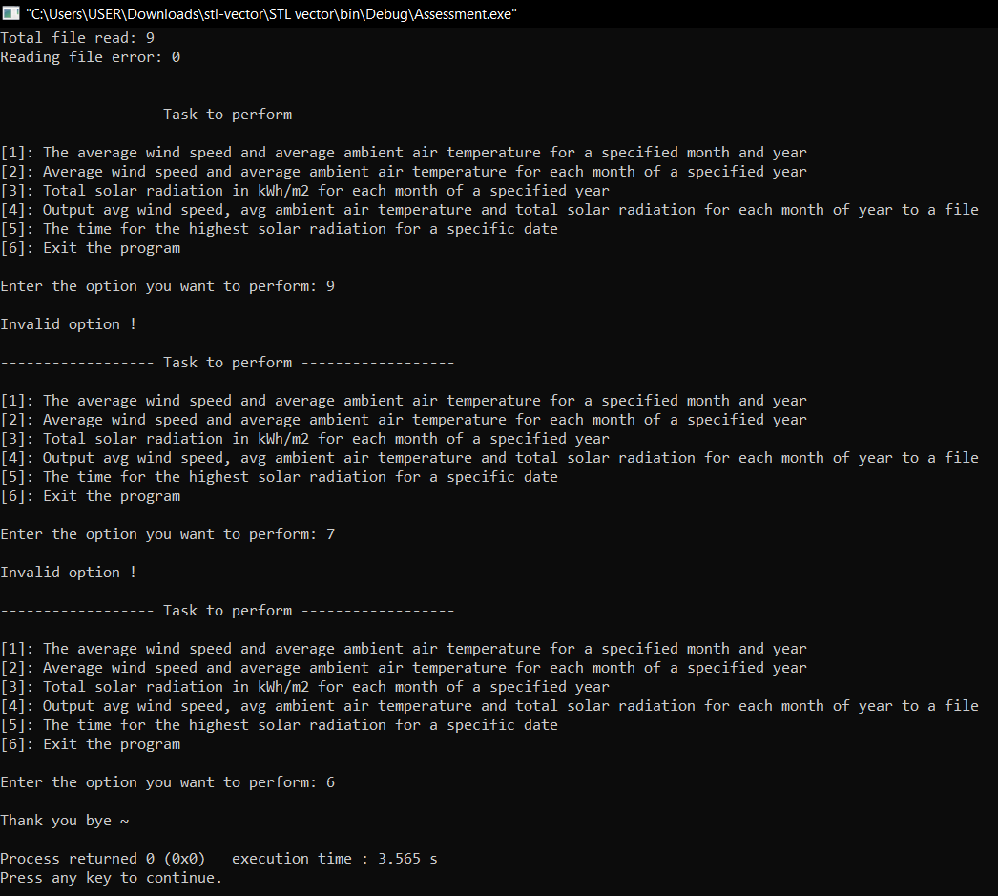
2. | 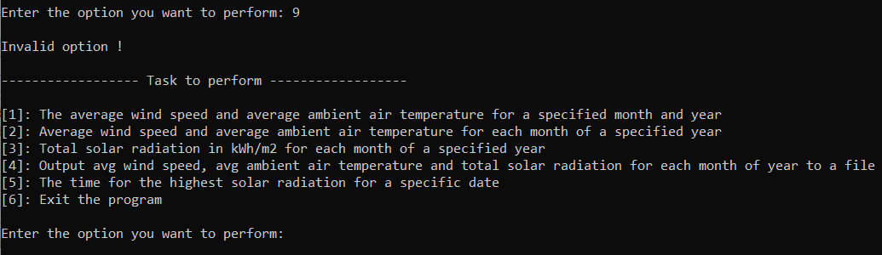
3. | 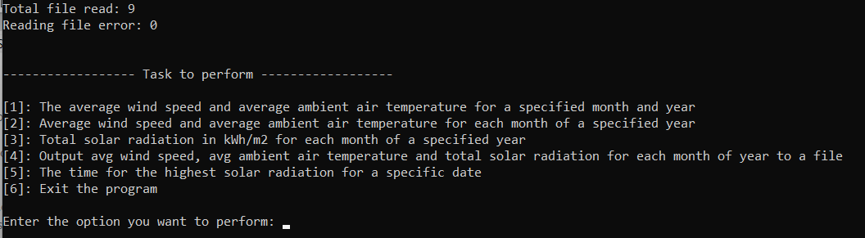

Test no. | Actual output
4. | 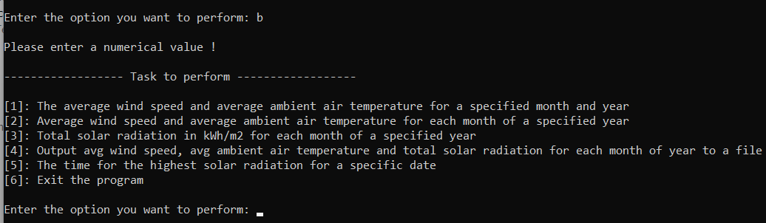
5. | 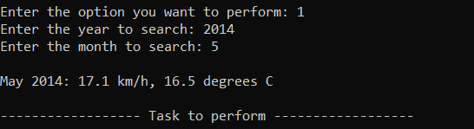
6. | 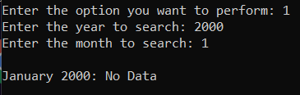
7. | 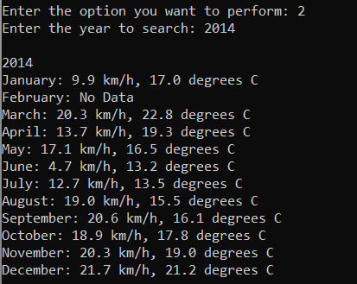

Test no. | Actual output
8. | 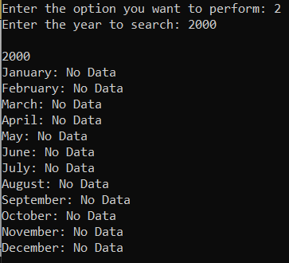
9. | 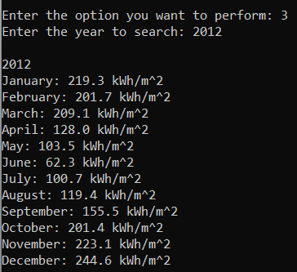
10. | 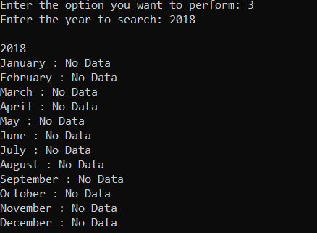

Test no. | Actual output
11. | 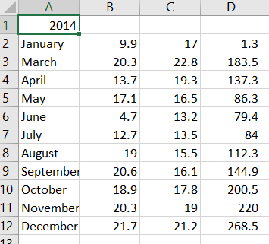
12. | 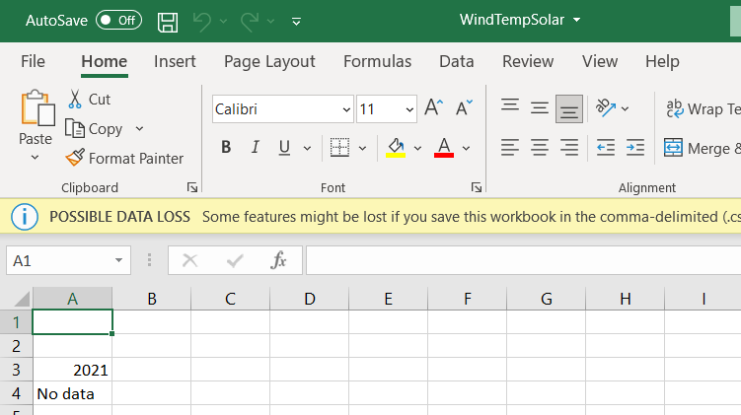
13. | 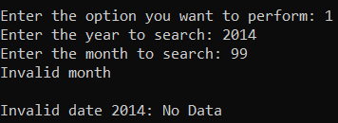
14. | 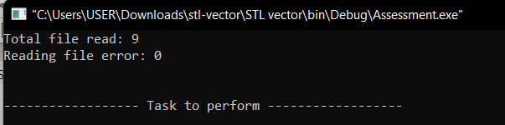

Test no. | Actual output
15. | 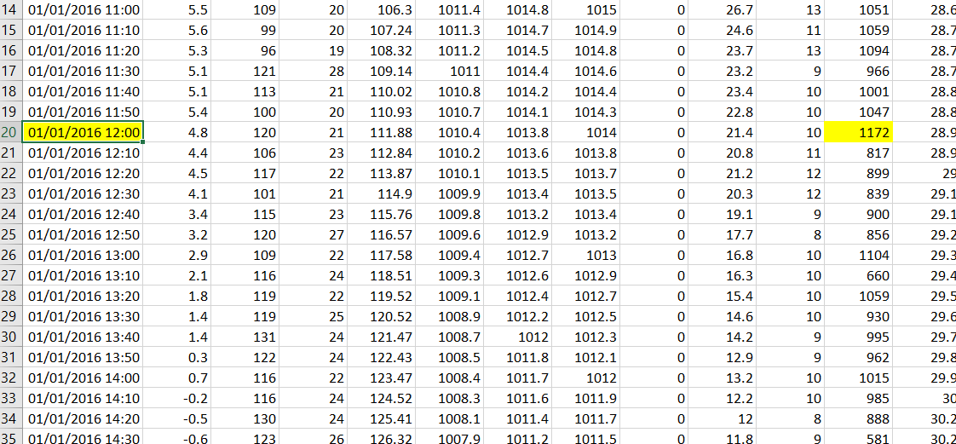  - Manually check  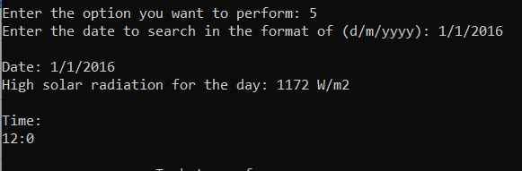

Test no. | Actual output
16. | 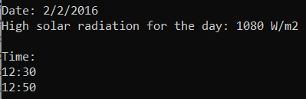  - Manually check  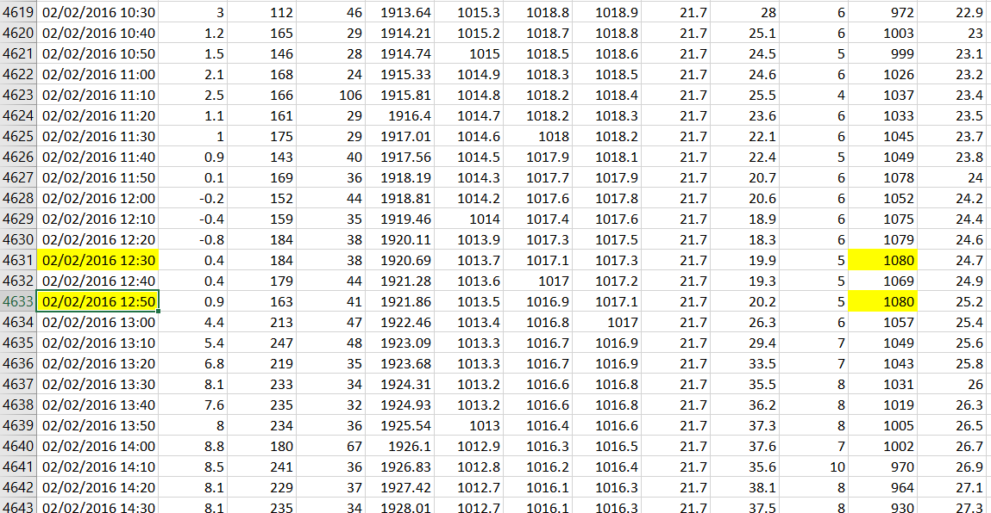
17. | 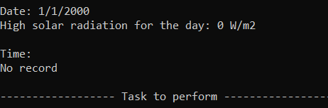

Test no. | Actual output
18. | 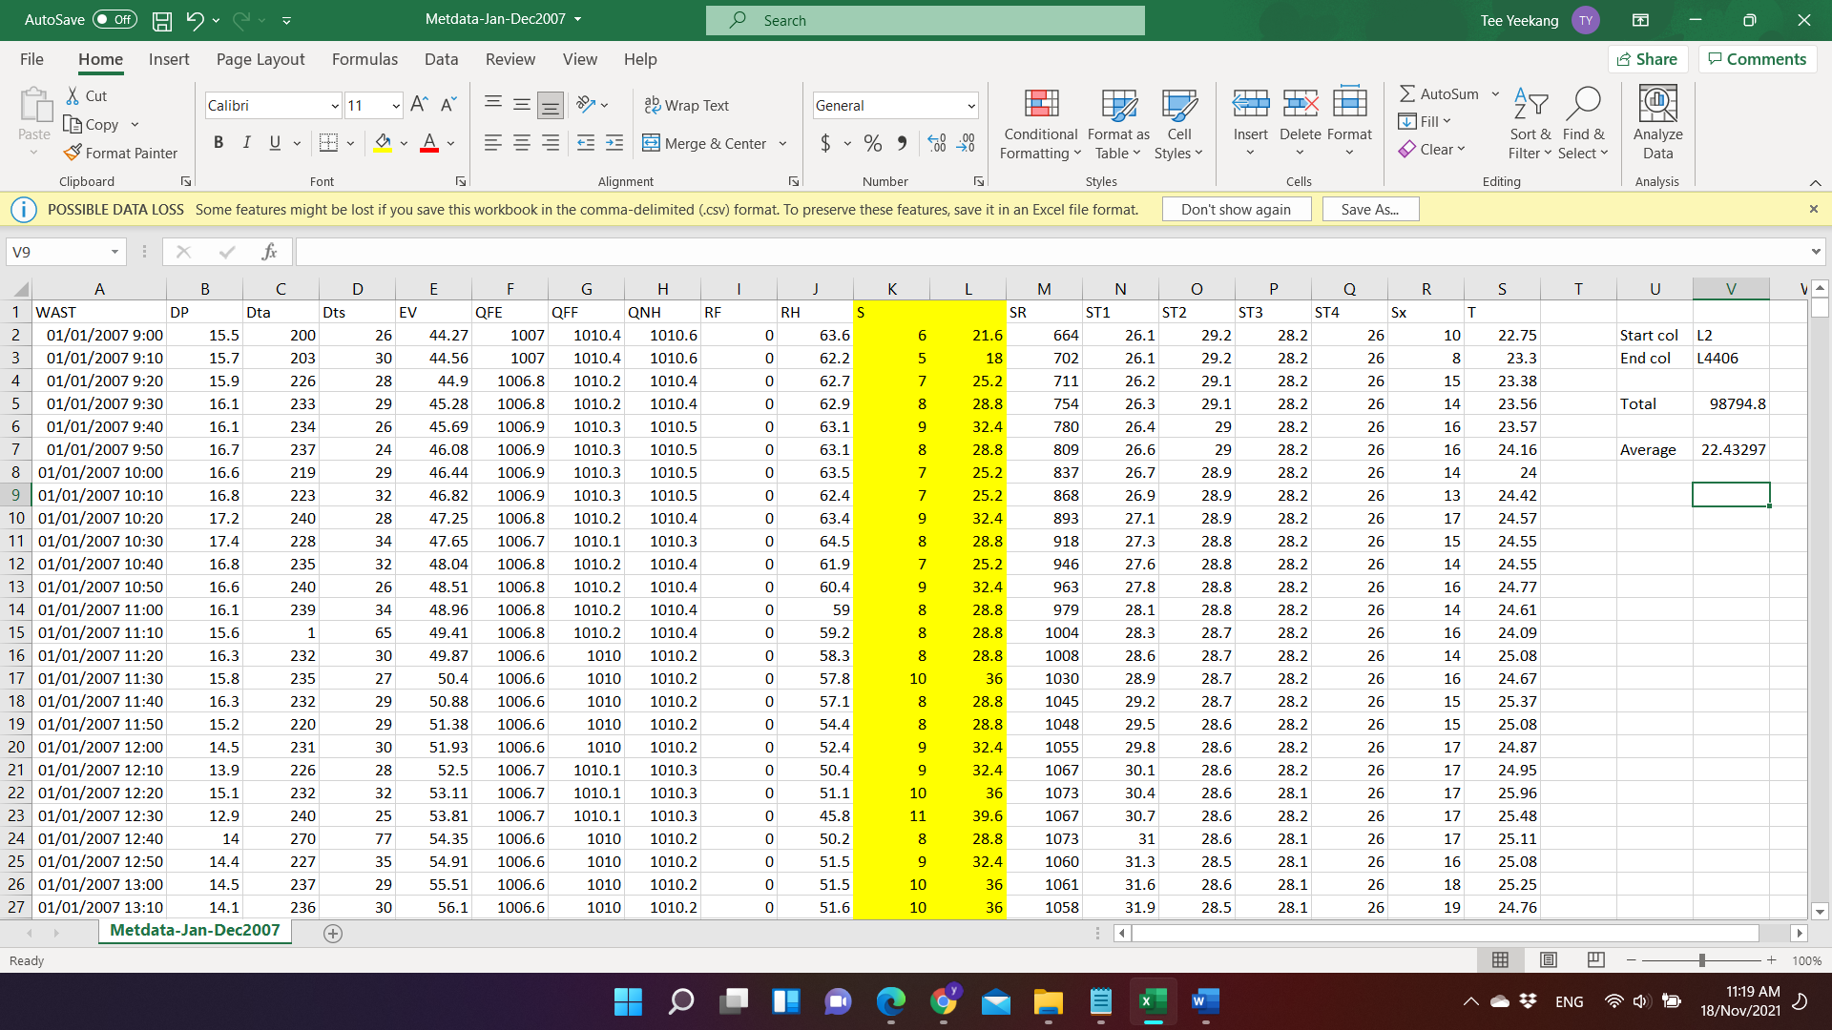
19. | 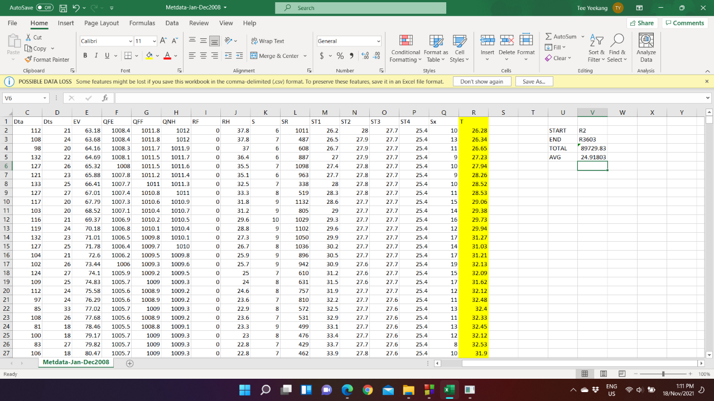

ICT283 Assignment 2, 2021
Student Name: Tee Yee Kang
Components | Comments
Evaluation (pros/cons) and rationale for data structures.
Program Design (determined from code and doxygen output) – Full Doxygen output in html is needed to get marks for this section.
Working Program (includes C++ code, coding style, comments, C++ classes, test plan) – Test plan and evaluation.txt need to be provided to get marks for this section.
BST: C++ Design, Implementation and use, including function pointers.
Use of STL map (or map variants like multimap)
Bonus Menu Option (only if all the 4 options are working.

Other advice (if any):

Number of days late: Late penalty (10 marks a day):

Final Grade:

